Chauhan Uday

Introduction to DBMS

Module 4 – Introduction to DBMS

1. Introduction to SQL
- What is SQL, and why is it essential in database management?
SQL (Structured Query Language) is a language used to talk to databases.
It helps you store, find, change, and delete data easily.
Why SQL is Important:
  - Manage data: Helps organize and control large amounts of data.
  - Find data: You can search for the exact information you need.
  - Change data: You can add, edit, or remove data anytime.
  - Create databases: You can make new tables and design how data is stored.
  - Keep data safe: You can give permission to only some people to use or change data.
  - Works everywhere: SQL works in almost all database systems like MySQL, Oracle, and SQL Server.
- Explain the difference between DBMS and RDBMS.

DBMS just stores data.
RDBMS stores data in tables and connects them together using relationships.

DBMS (Database RDBMS (Relational Database Management
Feature | Management System) | System)
Meaning | It is software that stores and manages data. | It is software that stores data in tables (rows and columns) and manages the relationships between them.
Data Storage | Data is stored as files. | Data is stored in tables.
Relationship Between Data | No relationship between data. | Maintains relationships using foreign keys.
High (same data may be
Data Redundancy Low (reduces repetition using relations).
repeated).
Uses file system to access
Data Access Uses SQL to access data.
data.
Examples dBase, File System MySQL, Oracle, SQL Server, PostgreSQL

- Describe the role of SQL in managing relational databases.
SQL (Structured Query Language) is a special language used to manage data stored in relational databases.
Think of SQL like a remote control that helps you control the database.
Here is what SQL helps you do:
- Store Data
SQL helps you add new data into tables.
(Like adding a new student's record)
- Read Data
SQL helps you find or view data from the database.
(Like searching for a student by name)
- Update Data
SQL helps you change/update data in the database.
(Like correcting a student's age)
- Delete Data
SQL helps you remove data you don’t need.
(Like removing a student who left school)
- Create Tables
SQL helps you build new tables to store different types of data.
- Control Access
SQL helps you decide who can access or change data — this keeps your data safe.
In short (very simple):
SQL is used to store, search, update, and manage data in relational databases. It makes database work easy, fast, and safe.
4. What are the key features of SQL?
SQL (Structured Query Language) is a powerful language used to manage and work with data stored in relational databases. It provides many important features that make data handling easy, fast, and reliable. The key features of SQL are:

1. Easy to Learn and Use
SQL uses simple English-like keywords such as SELECT, INSERT, UPDATE, DELETE, so it is very easy to understand and write.

2. Data Definition
SQL allows you to create, modify, and delete database objects such as tables and views. Commands: CREATE, ALTER, DROP

3. Data Manipulation
SQL helps to add, update, and delete data stored in tables.
Commands: INSERT, UPDATE, DELETE

4. Data Retrieval
SQL is mainly used to retrieve or fetch data from tables.
Command: SELECT (the most powerful and commonly used)

5. Data Control and Security
SQL provides commands to control user access, set permissions, and keep data safe. Commands: GRANT, REVOKE

6. Data Integrity
SQL supports rules to maintain the accuracy and correctness of data. Examples:
- PRIMARY KEY
- FOREIGN KEY
- UNIQUE
- NOT NULL
These rules prevent invalid or duplicate data.

7. High Performance
SQL can handle large amounts of data and perform operations very fast, even on complex queries. 8. Standard Language
SQL is a standard and widely used language supported by all major database systems like:
- MySQL
- SQL Server
- Oracle
- PostgreSQL
So SQL works almost the same everywhere.

9. Portability
SQL can be used on different computer systems, operating systems, and devices without major changes.

10. Support for Transactions
SQL supports transactions, which ensure all steps of a process are completed correctly.
Commands: COMMIT, ROLLBACK
This helps keep data safe and consistent.

LAB EXERCISES:
• Lab 1: Create a new database named school_db and a table called students with the following columns: student_id, student_name, age, class, and address.
- CREATE DATABASE school_db;
- CREATE TABLE students( student_id int PRIMARY KEY, student_name varchar(20), age int, class varchar(100), address varchar(100));
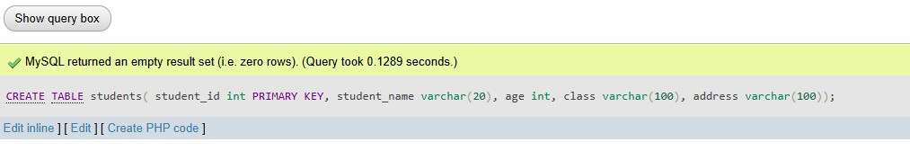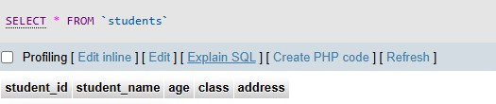

Lab 2: Insert five records into the students table and retrieve all records using the SELECT statement.
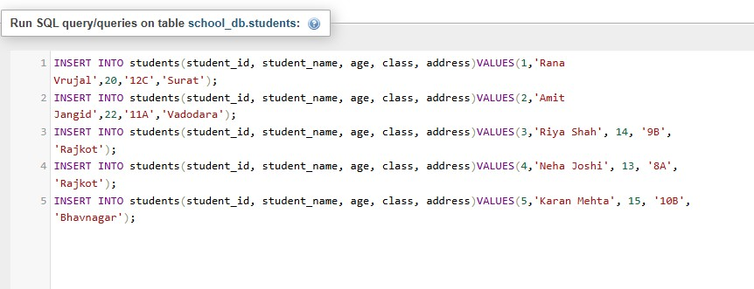

SELECT * FROM `students`;
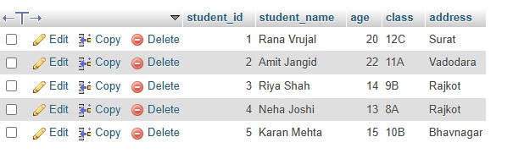

2. SQL Syntax
Theory Questions:
1. What are the basic components of SQL syntax?
SQL syntax has a few basic parts:

1. Keywords
These are special SQL words.
Example: SELECT, INSERT, UPDATE, DELETE, FROM, WHERE

2. Identifiers
Names of database objects.
Example: table name, column name
Like: students, age, student_name

3. Operators
Symbols used for comparison.
Example: = , > , < , >= , <= , <>

4. Values
The actual data you put inside the table.
Example: 'John', 20, 'India'

5. Clauses
Different parts of an SQL statement. Example:
- SELECT = What you want
- FROM = From which table
- WHERE = With what condition

6. Semicolon (;)
Used to end the SQL command. Example:
SELECT * FROM students; Very Short Easy Answer
SQL has 6 basic components:
- Keywords
- Identifiers
- Operators
- Values
- Clauses
- Semicolon
2. Write the general structure of an SQL SELECT statement.
Syntax: -
SELECT column1, column2, ...
FROM table_name
WHERE condition
GROUP BY column_name
HAVING condition
ORDER BY column_name ASC/DESC;
SELECT → which columns you want
FROM → from which table
WHERE → apply a condition (optional)
GROUP BY → group similar data (optional)
HAVING → condition on grouped data (optional)
ORDER BY → sort the result (optional)
3. Explain the role of clauses in SQL statements.
Clauses are different parts of an SQL statement.
Each clause has a special job and helps SQL understand what you want to do.

✅ Important Clauses and Their Roles

1. SELECT clause
• Tells SQL which columns you want. Example: SELECT name, age

2. FROM clause
• Tells SQL from which table to take the data. Example: FROM students

3. WHERE clause
• Used to filter data based on a condition. Example: WHERE age > 18

4. GROUP BY clause
• Used to group rows that have the same values.
Example: group by class.
5. HAVING clause
• Used to apply condition after grouping.

6. ORDER BY clause
• Used to sort the result in ascending or descending order. Example: ORDER BY age DESC
LAB EXERCISES:
Lab 1: Write SQL queries to retrieve specific columns (student_name and age) from the students table.
Query: -
SELECT student_name, age FROM students;
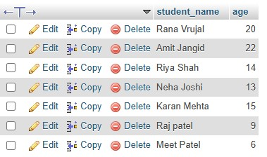
Lab 2: Write SQL queries to retrieve all students whose age is greater than 10.
Query: -
SELECT * FROM students WHERE age>10;
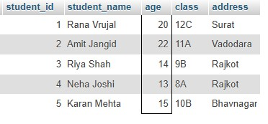

3. SQL Constraints
1. What are constraints in SQL? List and explain the different types of constraints.
Constraints are rules used in SQL to control what type of data can be stored in a table. They help keep the data correct, clean, and safe.
Types of Constraints
1. NOT NULL
The column cannot be empty.

2. UNIQUE
All values must be different.
No duplicate values allowed.

3. PRIMARY KEY
A special column that is NOT NULL + UNIQUE.
Used to identify each row.

4. FOREIGN KEY
Used to link two tables together.
It ensures data in both tables is connected correctly.

5. CHECK
Adds a rule to the column.
Example: age must be greater than 0.

6. DEFAULT
Gives a default value when no value is entered.
- Constraints = rules for data
- NOT NULL = cannot be empty
- UNIQUE = no duplicates
- PRIMARY KEY = unique identifier
- FOREIGN KEY = links tables
- CHECK = must follow condition
- DEFAULT = gives automatic value
- How do PRIMARY KEY and FOREIGN KEY constraints differ?
Feature | PRIMARY KEY | FOREIGN KEY
Purpose | Uniquely identifies each row | Connects two tables
Duplicates | Not allowed | Allowed
NULL values | Not allowed | Allowed (in most cases)
Where used? | In the main table | In another table to link back
Uniqueness | Must be unique | Does not need to be unique
Relation | Does NOT create relationship | Creates relationship between tables
Example | student_id in students table | student_id in marks table

- What is the role of NOT NULL and UNIQUE constraints?

1. NOT NULL Constraint
Role:
- Makes sure a column cannot be empty.
- You must enter a value.
Example:
A student must have a name → name cannot be empty.

2. UNIQUE Constraint
Role:
- Makes sure all values in the column are different.
- No duplicate values allowed.
Example:
Each student must have a different email → no two students can have the same email.
Constraint Role
NOT NULL Value cannot be empty UNIQUE No two values can be the same
LAB EXERCISES:
Lab 1: Create a table teachers with the following columns: teacher_id (Primary Key), teacher_name (NOT NULL), subject (NOT NULL), and email (UNIQUE).
Query: -
CREATE TABLE teachers (teacher_id int PRIMARY KEY, teacher_name varchar(50), subject VARCHAR(50), email VARCHAR(50) UNIQUE);
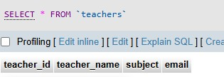
Lab 2: Implement a FOREIGN KEY constraint to relate the teacher_id from the teachers table with the students table.
Query: -
ALTER TABLE students ADD teacher_id INT;
ALTER TABLE students ADD CONSTRAINT fk_teacher FOREIGN KEY (teacher_id) REFERENCES teachers(teacher_id);
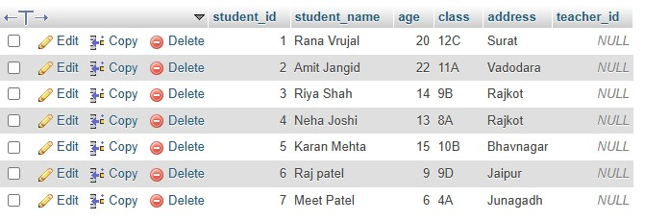

4. Main SQL Commands and Sub-commands (DDL)
Theory Questions:
1. Define the SQL Data Definition Language (DDL).
DDL is a part of SQL used to create, change, or delete database structures like tables, databases, and indexes.
It helps you define how the database will look.

Examples of DDL commands (simple words)
- CREATE → to make a new table or database
- ALTER → to change a table
- DROP → to delete a table or database • TRUNCATE → to remove all data from a table
- Explain the CREATE command and its syntax.
The CREATE command in SQL is used to make a new object in the database. You can create things like tables, databases, views, indexes, etc.
Most commonly, it is used to create a new table.
Example: -
CREATE TABLE students (
student_id INT, student_name VARCHAR(50), age INT
);
- What is the purpose of specifying data types and constraints during table creation?

1. Data Types
Data types are used to decide what kind of data can be stored in each column. Example: numbers, text, dates, decimals, etc.
- They help the database store data correctly
- They save storage space
- They prevent wrong data from being entered

2. Constraints
Constraints are rules applied to columns to control what values are allowed.
- They help keep the data correct and safe
- They prevent duplicate, empty, or invalid data
- They maintain relationships between tables
Example: -
- INT → only numbers
- VARCHAR → text
- NOT NULL → value cannot be empty
- UNIQUE → value cannot be repeated
- PRIMARY KEY → uniquely identifies each record
- FOREIGN KEY → links two tables

LAB EXERCISES:
Lab 1: Create a table courses with columns: course_id, course_name, and course_credits. Set the course_id as the primary key.
CREATE TABLE courses(course_id int PRIMARY KEY AUTO_INCREMENT, course_name varchar(100),
course_credits int);
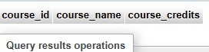

Lab 2: Use the CREATE command to create a database university_db.
CREATE DATABASE university_db;
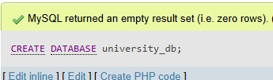

5. ALTER Command
Theory Questions:
- What is the use of the ALTER command in SQL?
The ALTER command is used to change an existing table.
It helps you update the table structure without deleting the table.
What you can do with ALTER:
  - Add a new column
  - Delete a column
  - Change a column’s data type
  - Rename a column or table
  - Add or remove constraints (like PRIMARY KEY, FOREIGN KEY)
Example: -
ALTER TABLE students ADD email VARCHAR(50);

- How can you add, modify, and drop columns from a table using ALTER?

1. Add a Column
Use ADD to insert a new column into an existing table.
ALTER TABLE table_name ADD column_name datatype;
Example:
ALTER TABLE students
ADD email VARCHAR(100);

2. Modify (Change) a Column
Use MODIFY (MySQL) or ALTER COLUMN (SQL Server/PostgreSQL) to change a column’s datatype or size.
MySQL Syntax:
ALTER TABLE table_name MODIFY column_name new_datatype; Example:
ALTER TABLE students MODIFY email VARCHAR(150);

3. Drop (Delete) a Column
Use DROP COLUMN to remove a column from the table.
ALTER TABLE table_name DROP COLUMN column_name;
Example:
ALTER TABLE students DROP COLUMN email;
- How to rename a column
- How to add or remove constraints using ALTER Just tell me!
LAB EXERCISES:
Lab 1: Modify the courses table by adding a column course_duration using the ALTER command.
ALTER TABLE courses ADD course_duration varchar(50);
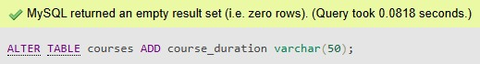

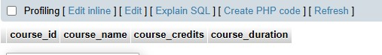
Lab 2: Drop the course_credits column from the courses table.
ALTER TABLE courses DROP COLUMN course_credits;
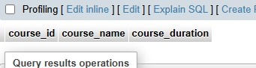

6. DROP Command Theory Questions:
- What is the function of the DROP command in SQL?
The DROP command is used to permanently delete a database object. It removes the object completely from the database.
  - You can DROP:
  - A table
  - A database
  - A view
  - An index
  - A column (using ALTER TABLE … DROP COLUMN)

  - Example:

DROP TABLE students;
This deletes the entire table and all its data.
- What are the implications of dropping a table from a database?
- The table is permanently deleted
You cannot recover it unless you have a backup.
- All data inside the table is lost
Every record stored in that table is removed forever.
- All constraints linked to the table are removed
Primary keys, foreign keys, and indexes related to that table are deleted.

4. Other tables may be affected
If any table depends on it through a foreign key, errors can occur unless the foreign key is removed first.
LAB EXERCISES:
Lab 1: Drop the teachers table from the school_db database.
DROP TABLE teachers;
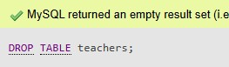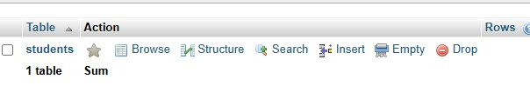

Lab 2: Drop the students table from the school_db database and verify that the table has been removed.

Drop the students table
DROP TABLE students;

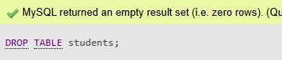

Verify that the table has been removed
Use this command to list all tables:
SHOW TABLES;
7. Data Manipulation Language (DML)

Theory Questions:

1. Define the INSERT, UPDATE, and DELETE commands in SQL.

INSERT Command
The INSERT command is used to add new rows into a table. It stores new data in the database.
Example:
INSERT INTO table_name (columns) VALUES (values);

UPDATE Command
The UPDATE command is used to change or modify existing data in a table.
It updates only the rows that match the condition.
Example:
UPDATE table_name SET column = value WHERE condition;

DELETE Command
The DELETE command is used to remove rows from a table.
It deletes only the data you select with a condition.
Example:
DELETE FROM table_name WHERE condition;

2. What is the importance of the WHERE clause in UPDATE and DELETE operations?
The WHERE clause is very important in UPDATE and DELETE commands because it tells the database which specific rows should be updated or deleted.
Without the WHERE clause:
- UPDATE will change all rows in the table
- DELETE will remove all rows from the table
So, the WHERE clause helps to:
- Prevent accidental changes
- Protect the data
- Update or delete only the required records
LAB EXERCISES:
Lab 1: Insert three records into the courses table using the INSERT command.
INSERT INTO courses (course_name,course_duration)VALUES('web development','3 months');
INSERT INTO courses (course_name,course_duration)VALUES('maths','1 months');
INSERT INTO courses (course_name,course_duration)VALUES('php','3 months');

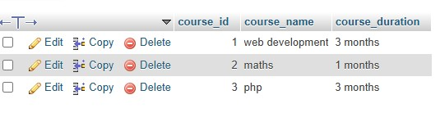
Lab 2: Update the course duration of a specific course using the UPDATE command.
UPDATE courses SET course_duration='8 months' WHERE course_name='web development';
UPDATE courses SET course_duration='2 months' WHERE course_name='maths';
UPDATE courses SET course_duration='5 months' WHERE course_name='php';
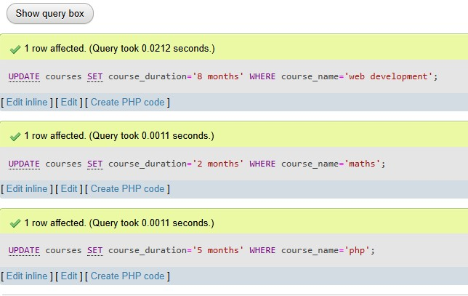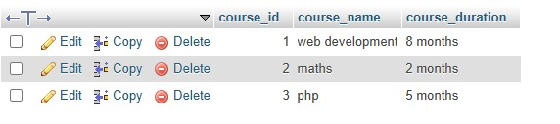

Lab 3: Delete a course with a specific course_id from the courses table using the DELETE command. DELETE FROM courses WHERE course_id=2;

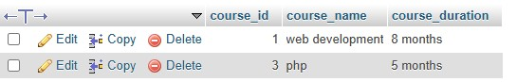

8. Data Query Language (DQL)
Theory Questions:
- What is the SELECT statement, and how is it used to query data?
The SELECT statement is used to get data from a table in a database.
It helps you choose which information you want to see.
Example:
SELECT * FROM courses;
This shows all the data from the courses table.
In Easy Words:
  - SELECT = show data
  - It helps you look inside a table.
  - You can choose specific columns or specific rows.
- Explain the use of the ORDER BY and WHERE clauses in SQL queries.
The WHERE clause is used to filter data.
It shows only the rows that match a condition.
Easy Words:
  - WHERE = filter the data
  - Shows only the records you want.
Example:
SELECT * FROM courses
WHERE course_id = 2;

→ Use of the ORDER BY Clause
The ORDER BY clause is used to sort data.
You can sort data in ascending (ASC) or descending (DESC) order.
Easy Words:
  - ORDER BY = sort the data
  - Helps arrange results from small to big or A to Z.
Example:
SELECT * FROM courses ORDER BY course_name ASC;

LAB EXERCISES:
Lab 1: Retrieve all courses from the courses table using the SELECT statement.
SELECT * FROM courses;
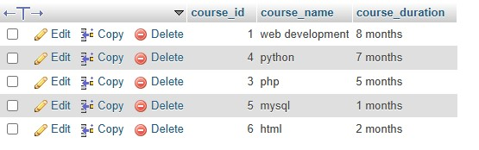
Lab 2: Sort the courses based on course_duration in descending order using ORDER BY.
SELECT * FROM courses ORDER BY course_duration DESC;
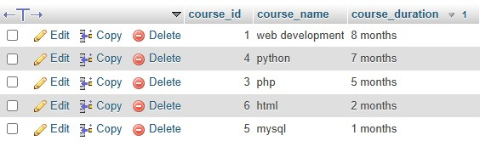
Lab 3: Limit the results of the SELECT query to show only the top two courses using LIMIT. SELECT * FROM courses LIMIT 2;
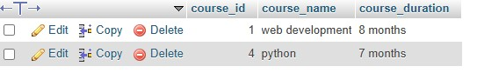

9. Data Control Language (DCL)
Theory Questions:
- What is the purpose of GRANT and REVOKE in SQL?
Purpose of GRANT in SQL
GRANT is used to give permissions to a user.
It allows a user to perform actions like SELECT, INSERT, UPDATE, DELETE, etc.
Easy Words:
  - GRANT = give permission
Purpose of REVOKE in SQL
REVOKE is used to take back permissions from a user. It removes the rights that were earlier given.
Easy Words:
  - REVOKE = remove permission
- How do you manage privileges using these commands?
You manage privileges by giving and removing permissions for users in the database.
Easy Words:
  - Use GRANT to allow a user to do something.
  - Use REVOKE to stop a user from doing something.
Example:
Give permission (GRANT):
GRANT SELECT, INSERT ON courses TO user1;
This allows user1 to select and insert data in the courses table.
Remove permission (REVOKE):
REVOKE INSERT ON courses FROM user1; This removes the INSERT right from user1.
LAB EXERCISES:
Lab 1: Create two new users user1 and user2 and grant user1 permission to SELECT from the courses table.
CREATE USER 'user1'@'localhost' IDENTIFIED BY 'password1';
CREATE USER 'user2'@'localhost' IDENTIFIED BY 'password2';
GRANT SELECT ON university_db.courses TO 'user1'@'localhost';

Lab 2: Revoke the INSERT permission from user1 and give it to user2. REVOKE INSERT ON school_db.courses FROM 'user1'@'localhost';
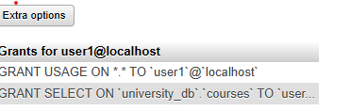
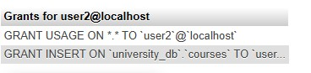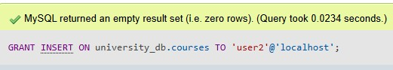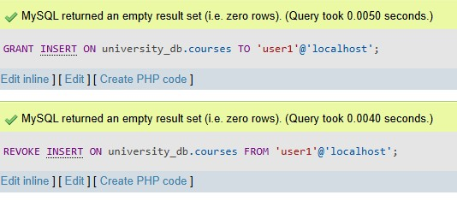

10. Transaction Control Language (TCL)
Theory Questions:
1. What is the purpose of the COMMIT and ROLLBACK commands in SQL?

COMMIT
- Definition: COMMIT is used to save all the changes made in the current transaction permanently to the database.
- Purpose: Ensures that your changes (INSERT, UPDATE, DELETE) are final and cannot be undone.
- Example:
START TRANSACTION;

INSERT INTO courses (course_id, course_name) VALUES (1, 'Mathematics');
INSERT INTO courses (course_id, course_name) VALUES (2, 'Physics');

COMMIT; -- Changes are saved permanently
- Key point: Once you commit, the changes are permanent.

ROLLBACK
- Definition: ROLLBACK is used to undo changes made in the current transaction.
- Purpose: It reverts the database to its previous state, before the transaction started.
- Example:
START TRANSACTION;

INSERT INTO courses (course_id, course_name) VALUES (3, 'Chemistry');

ROLLBACK; -- The insertion is undone
- Key point: Useful when something goes wrong, like an error in data or logic.

Summary Table
Command Purpose Effect on Database
COMMIT Save all changes permanently Changes cannot be undone
ROLLBACK Undo all changes in the current transaction Database returns to previous state

In short:
- COMMIT → Save changes permanently
- ROLLBACK → Cancel changes and restore old data
2. Explain how transactions are managed in SQL databases.
What is a Transaction?
- A transaction is a logical unit of work in a database.
- It consists of one or more SQL statements that must either all succeed or all fail.
- Example: Transferring money from one account to another:
  - Deduct amount from Account A
  - Add amount to Account B
→ Both steps must succeed, or neither should happen. ACID Properties
Transactions are managed using ACID principles to ensure reliability:
Property Meaning
A – Atomicity All operations in a transaction succeed or fail as a single unit.
C –
Database moves from one valid state to another after a transaction.
Consistency
I – Isolation Transactions are executed independently without interfering with each other.
Once a transaction is committed, the changes are permanent even if the system – Durability crashes. D

Transaction Control Commands
SQL provides commands to manage transactions:
Command Purpose
START TRANSACTION / BEGIN Begin a new transaction
COMMIT | Save all changes permanently
ROLLBACK | Undo changes made in the current transaction
SAVEPOINT | Set a point in a transaction to roll back to partially

How Transactions Are Managed
- Start Transaction
- START TRANSACTION;
- Execute SQL statements
- INSERT INTO accounts VALUES (1, 'A', 5000);
- UPDATE accounts SET balance = balance - 500 WHERE id = 1;
- UPDATE accounts SET balance = balance + 500 WHERE id = 2;
- Check for errors o If everything is correct → COMMIT o If an error occurs → ROLLBACK
- Optional SAVEPOINT
o Allows partial rollback within a transaction:
- SAVEPOINT sp1;
- -- some operations
- ROLLBACK TO sp1;

Example
START TRANSACTION;

UPDATE accounts SET balance = balance - 1000 WHERE id = 1;
UPDATE accounts SET balance = balance + 1000 WHERE id = 2;

-- Suppose an error occurs here
ROLLBACK; -- Undo both updates

-- If no error
COMMIT; -- Save changes permanently

Summary
- Transactions ensure data integrity.
- SQL provides commands (START TRANSACTION, COMMIT, ROLLBACK) to control changes safely.
- ACID properties guarantee reliability, consistency, and durability.
LAB EXERCISES:
Lab 1: Insert a few rows into the courses table and use COMMIT to save the changes.
START TRANSACTION;
INSERT INTO courses (course_name,course_duration) VALUES ('java','7 months');
INSERT INTO courses (course_name,course_duration) VALUES ('mern','10 months');
INSERT INTO courses (course_name,course_duration) VALUES ('css',' 2 months');
COMMIT;

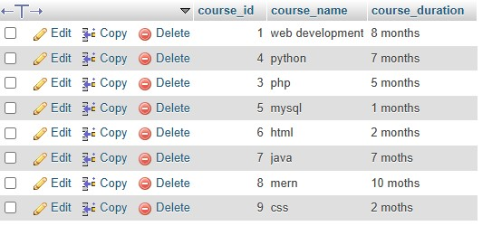

Lab 2: Insert additional rows, then use ROLLBACK to undo the last insert operation.
INSERT INTO courses (course_name,course_duration) VALUES ('Biology', '5 months');
INSERT INTO courses (course_name,course_duration) VALUES ('Computer Science', '8 months'); ROLLBACK;
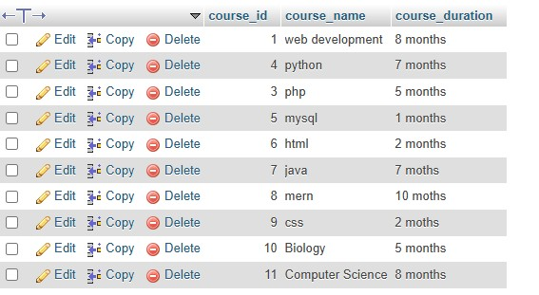

Lab 3: Create a SAVEPOINT before updating the courses table, and use it to roll back specific changes.
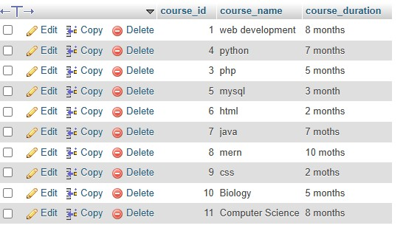
11. SQL Joins
Theory Questions:
1. Explain the concept of JOIN in SQL. What is the difference between INNER JOIN, LEFT JOIN, RIGHT JOIN, and FULL OUTER JOIN?

Types of JOIN and Their Differences

1️ INNER JOIN
- Returns only the matching rows from both tables.
- Rows that do not match are excluded.

2️ LEFT JOIN (LEFT OUTER JOIN)
- Returns all rows from the left table, and the matching rows from the right table.
- If no match exists, values from the right table are shown as NULL.

3️ RIGHT JOIN (RIGHT OUTER JOIN)
- Returns all rows from the right table, and the matching rows from the left table.
- If no match exists, values from the left table are shown as NULL.

4️ FULL OUTER JOIN
- Returns all rows from both tables.
- Matching rows are combined.
- Non-matching rows from both tables are shown with NULL values.

Difference in One Simple Table
JOIN Type Shows Matching Rows Shows Unmatched Left Shows Unmatched Right
INNER JOIN ✔ | ✖ | ✖
LEFT JOIN ✔ | ✔ | ✖
RIGHT JOIN ✔ | ✖ | ✔
FULL OUTER JOIN ✔ | ✔ | ✔

2. How are joins used to combine data from multiple tables?
Joins are used to combine data from multiple tables by matching rows based on a common column (usually a primary key–foreign key relationship).
SQL reads both tables, finds the related values, and returns a single result set containing data from all the joined tables.

How it works
- Each table stores different information (e.g., students in one table and classes in another).
- A JOIN compares the related columns (like _{class_id}).
- It combines the matching rows into one output using the join condition:
SELECT columns
FROM table1
JOIN table2
ON table1.common_column = table2.common_column;

Why joins are used
- To avoid storing duplicate data
- To connect related information
- To retrieve complete results from normalized databases
LAB EXERCISES:
Lab 1: Create two tables: departments and employees. Perform an INNER JOIN to display employees along with their respective departments.
Department table: -
Table create: -
CREATE TABLE departments (dept_id int PRIMARY KEY AUTO_INCREMENT, dept_name varchar(50));
Data insert: -
INSERT INTO departments (dept_name) VALUES ('HR');
INSERT INTO departments (dept_name) VALUES ('Finance');
INSERT INTO departments (dept_name) VALUES ('IT');
INSERT INTO departments (dept_name) VALUES ('Account');

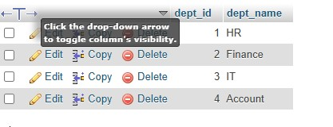
Employees table: -
Table: -
CREATE TABLE employees(emp_id int PRIMARY KEY AUTO_INCREMENT, emp_name varchar(50), dept_id int, FOREIGN KEY(dept_id) REFERENCES departments(dept_id));
Data insert: -
INSERT INTO employees (emp_name,dept_id) VALUES ('Amit',1);
INSERT INTO employees (emp_name,dept_id) VALUES ('Harsh',3);
INSERT INTO employees (emp_name,dept_id) VALUES ('Harshda',2);
INSERT INTO employees (emp_name,dept_id) VALUES ('Raj',1);
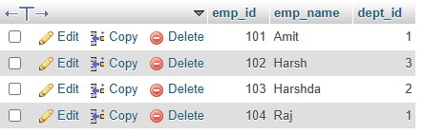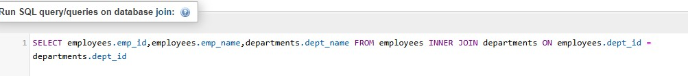

SELECT employees.emp_id,employees.emp_name,departments.dept_name FROM employees INNER JOIN departments ON employees.dept_id = departments.dept_id
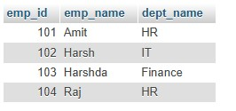
Lab 2: Use a LEFT JOIN to show all departments, even those without employees.
SELECT departments.dept_id, departments.dept_name,employees.emp_name FROM departments LEFT JOIN employees ON departments.dept_id = employees.dept_id;
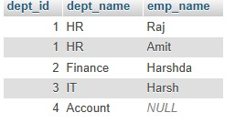

12. SQL Group By
Theory Questions:
1. What is the GROUP BY clause in SQL? How is it used with aggregate functions?
The GROUP BY clause in SQL is used to group rows that have the same values in one or more columns.
It allows you to organize data into groups so that you can apply aggregate functions to each group separately.
Aggregate functions include:
- COUNT() – counts rows
- SUM() – adds values
- AVG() – finds average
- MAX() – highest value
- MIN() – lowest value
When GROUP BY is used with these functions, SQL returns one result per group instead of one result per row.

✅ Example
SELECT department, COUNT(emp_id) AS total_employees
FROM employees
GROUP BY department; Explanation
- The _{department} column is used to create groups.
- _{COUNT(emp_id)} calculates the number of employees in each department.
- The output displays each department once, along with its total employees.

✅ Perfect Summary
- GROUP BY groups similar rows.
- Aggregate functions calculate values for each group.
- Commonly used for reports like totals, averages, and counts.
2. Explain the difference between GROUP BY and ORDER BY.

1️ ⃣ GROUP BY
- Used to group rows that have the same values in one or more columns.
- Mostly used with aggregate functions like COUNT(), SUM(), AVG(), MAX(), MIN().
- Output shows one row per group.
Purpose:
To summarize or aggregate data.
Example:
Group employees by department.
SELECT department, COUNT(*)
FROM employees
GROUP BY department;

2️ ⃣ ORDER BY
- Used to sort the result in ascending (ASC) or descending (DESC) order.
- Does not perform grouping or aggregation.
- Works on individual rows or on grouped results.
Purpose:
To arrange data in a specific order.
Example:
Sort employees by name.
SELECT * FROM employees
ORDER BY emp_name ASC;

✅ Key Differences
Feature | GROUP BY | ORDER BY
Function | Groups rows | Sorts rows
Used with | Aggregate functions | Any column or expression
Output | One row per group | Same rows, just sorted
Feature GROUP BY ORDER BY
Order of Use Comes before ORDER BY in SQL Comes after GROUP BY

✅ Perfect Summary
- GROUP BY = Grouping + Aggregation
- ORDER BY = Sorting the output

LAB EXERCISES:
Lab 1: Group employees by department and count the number of employees in each department using GROUP BY. SELECT dept_id,COUNT(emp_id) AS total_employees FROM employees GROUP BY dept_id;
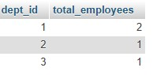
Lab 2: Use the AVG aggregate function to find the average salary of employees in each department
ALTER TABLE employees ADD salary INT;
UPDATE employees SET salary = 30000 WHERE emp_id = 101;
UPDATE employees SET salary = 45000 WHERE emp_id = 102;
UPDATE employees SET salary = 50000 WHERE emp_id = 103;
UPDATE employees SET salary = 32000 WHERE emp_id = 104;
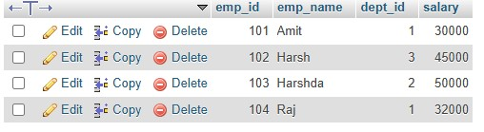
SELECT dept_id, AVG(salary) AS average_salary FROM employees GROUP BY dept_id;
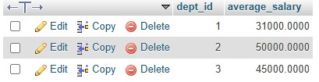

13. SQL Stored Procedure
Theory Questions:
1. What is a stored procedure in SQL, and how does it differ from a standard SQL query?

Stored Procedure (Definition)
A stored procedure is a pre-written, reusable block of SQL code that is stored in the database and can be executed whenever needed.
It may contain multiple SQL statements such as _{SELECT}, _{INSERT}, _{UPDATE}, _{DELETE}, along with logic like conditions and loops.

✅ How it differs from a standard SQL query
Feature Stored Procedure | Standard SQL Query
Definition Predefined program stored in the database | A single SQL command written and executed manually
Execution Run using a call (e.g., CALL procedure_name;) | Executed directly in the SQL editor
Reusability Highly reusable; written once, used many times | Must be written each time you want to run it
Performance Faster — compiled and cached by the database | Slower — executed and parsed each time
Complexity Can include multiple statements, loops, conditions | Usually one simple statement
Can restrict direct table access and allow controlled  Security execution | Gives direct access to tables

✅ Perfect Summary
- A stored procedure is a reusable program saved in the database.
- A standard SQL query is a one-time command you execute manually.
- Stored procedures are faster, more secure, and used for automation.
2. Explain the advantages of using stored procedures.
Stored procedures offer several benefits that make database operations faster, safer, and more organized. 1️ ⃣ Improved Performance
- Stored procedures are precompiled and stored in the database.
- They run faster than writing SQL queries again and again.

2️ ⃣ Reusability
- Write once, use many times.
- The same procedure can be called multiple times by different programs or users.

3️ ⃣ Better Security
- Users can be given permission to execute a procedure without accessing tables directly.
- Helps protect sensitive data.

4️ ⃣ Reduced Network Traffic
- Instead of sending multiple SQL queries over the network, the client only sends: CALL procedure_name;
- This reduces data transfer and speeds up execution.

5️ ⃣ Maintains Consistency
- Business logic is stored in one place.
- Ensures that all programs follow the same rules and calculations.

6️ ⃣ Easier Maintenance
- If logic changes, update the stored procedure once.
- All applications automatically use the updated logic.

LAB EXERCISES:
Lab 1: Write a stored procedure to retrieve all employees from the employees table based on department. DELIMITER $$

CREATE PROCEDURE GetEmployeesByDept(IN dept INT)
BEGIN
SELECT emp_id, emp_name, dept_id
FROM employees
WHERE dept_id = dept;
END$$

DELIMITER ;

CALL GetEmployeesByDept(1);
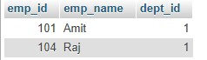
Lab 2: Write a stored procedure that accepts course_id as input and returns the course details
DELIMITER $$

CREATE PROCEDURE GetEmployeesByDept(IN dept INT)
BEGIN
SELECT emp_id, emp_name, dept_id
FROM employees
WHERE dept_id = dept;
END$$

DELIMITER ;
CALL GetCourseDetails(1);
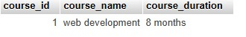

14. SQL View
Theory Questions:
1. What is a view in SQL, and how is it different from a table?
A view is a virtual table in SQL that is created from a _{SELECT} query.
It does not store data physically; it only shows data stored in other tables.
✅ How is a View different from a Table?
View Table
Virtual table (logical) Physical table (actual data stored)
View Table
Stores no data Stores real data
Created using CREATE VIEW Created using CREATE TABLE
Automatically updates when underlying table changes Data changes only when inserted/updated manually

2. Explain the advantages of using views in SQL databases.
- Security
- Views allow you to hide sensitive columns and show only required data to specific users.
- Simplicity
- Complex queries can be saved as a view, making it easy to reuse with a simple _{SELECT}.
- Data Consistency
- Since views pull data from base tables, the displayed data is always up-to-date.
- Logical Independence
- You can change the underlying table structure without affecting user queries using the view.
- Reusability
- Once created, views can be used multiple times like a table, saving time.
- Improves Query Readability
- Reduces complexity and makes long SQL queries easier to understand.

LAB EXERCISES:
Lab 1: Create a view to show all employees along with their department names.
CREATE VIEW employee_department_view AS SELECT e.emp_id, e.emp_name,
d.dept_name
FROM employees e
JOIN departments d
ON e.dept_id = d.dept_id;
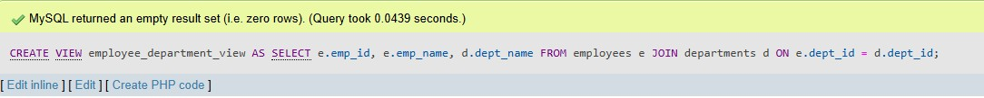
SELECT * FROM employee_department_view;
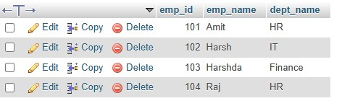
Lab 2: Modify the view to exclude employees whose salaries are below $50,000.
First: -
DROP VIEW IF EXISTS employee_department_view;
Second: -
CREATE VIEW employee_department_view AS SELECT e.emp_id, e.emp_name,
d.dept_name
FROM employees e
JOIN departments d
ON e.dept_id = d.dept_id
WHERE e.salary >= 50000;
SELECT * FROM employee_department_view;
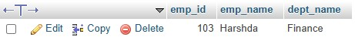

15. SQL Triggers
Theory Questions:
1. What is a trigger in SQL? Describe its types and when they are used.
1. What is a Trigger in SQL?
A trigger is an automatic procedure in SQL that runs when a specific event happens on a table, such as INSERT, UPDATE, or DELETE.
Triggers help automate tasks, maintain data integrity, and perform auditing.

Types of Triggers and When They Are Used
- BEFORE Trigger
Runs before an INSERT, UPDATE, or DELETE occurs. Used for:
  - Validating data
  - Modifying values before saving
  - Preventing invalid actions
- AFTER Trigger
Runs after an INSERT, UPDATE, or DELETE completes. Used for:
  - Storing logs
  - Auditing changes
  - Sending notifications or updates
- INSTEAD OF Trigger
Used mainly with views and runs instead of the actual operation. Used for:
  - Handling changes on complex views
  - Custom customized logic for insert/update/delete on views

2. Explain the difference between INSERT, UPDATE, and DELETE triggers.
Trigger Type When It Executes What It Is Used For Example Use Case
INSERT When a new row is Validate new data, set default values, Add a log entry whenever a new
Trigger inserted create log records employee is added
UPDATE When an existing row Track changes, store old & new values, Save old salary before updating
Trigger is updated validate updates to new salary
Trigger Type When It Executes What It Is Used For Example Use Case
DELETE When a row is Prevent accidental deletes, create delete Move deleted records to a
Trigger deleted logs, backup deleted data backup table

LAB EXERCISES:
Lab 1: Create a trigger to automatically log changes to the employees table when a new employee is added. DELIMITER $$

CREATE TRIGGER log_new_employee
AFTER INSERT ON employees
FOR EACH ROW
BEGIN
INSERT INTO employee_log (emp_id, action, action_time)
VALUES (NEW.emp_id, 'New Employee Added', NOW());
END$$

DELIMITER ;
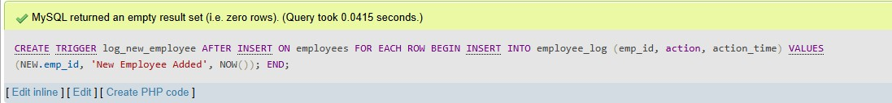
SHOW TRIGGERS;
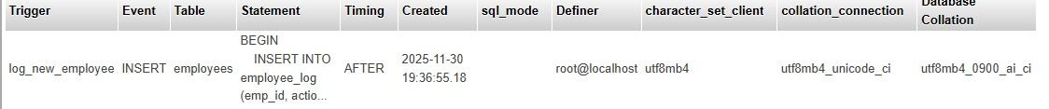
SHOW TRIGGERS LIKE 'employees';
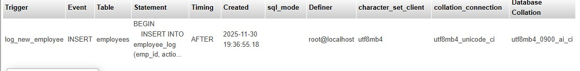
SHOW CREATE TRIGGER log_new_employee;

Lab 2: Create a trigger to update the last_modified timestamp whenever an employee record is updated.
First to add the new colunm: -
ALTER TABLE employees ADD COLUMN last_modified DATETIME;

DELIMITER $$

CREATE TRIGGER update_last_modified
BEFORE UPDATE ON employees
FOR EACH ROW
BEGIN
SET NEW.last_modified = NOW();
END$$

DELIMITER ;
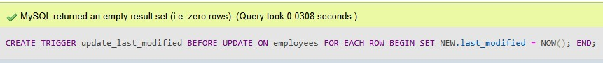
SHOW TRIGGERS LIKE 'employees';
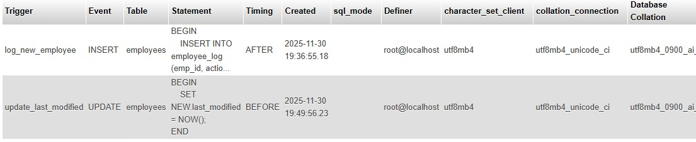

UPDATE employees SET salary = 200000 WHERE emp_id = 101;

SELECT emp_id, emp_name, salary, last_modified FROM employees WHERE emp_id = 101;

16. Introduction to PL/SQL
Theory Questions:
1. What is PL/SQL, and how does it extend SQL's capabilities?
What is PL/SQL?
PL/SQL (Procedural Language/SQL) is Oracle’s procedural extension of SQL.
It allows you to write blocks of code with variables, loops, and control structures, which standard SQL alone cannot do.

How PL/SQL Extends SQL’s Capabilities
- Procedural Programming – Supports _{IF…ELSE}, loops (_{FOR}, _{WHILE}), and exception handling.
- Variables and Constants – Store values temporarily for computations.
- Modular Programming – Create procedures, functions, and packages for reusable code.
- Error Handling – Use _{EXCEPTION} blocks to manage runtime errors.
- Automation – Combine multiple SQL statements in a single block for batch operations.
2. List and explain the benefits of using PL/SQL.

Benefits of Using PL/SQL
- Combines SQL and Procedural Features o Allows using SQL for database operations and procedural constructs like loops, conditions, and variables.
- Improves Performance o Multiple SQL statements can be executed in a single PL/SQL block, reducing network traffic.
- Reusability and Modularity o Supports procedures, functions, packages, and triggers for reusable code.
- Error Handling o Provides _{EXCEPTION} blocks to handle runtime errors gracefully.
- Enhanced Security o Code can be stored in the database as procedures/functions, hiding business logic from users.
- Easier Maintenance o Modular blocks make updates and debugging simpler.
- Transaction Control o Supports _{COMMIT}, _{ROLLBACK}, and _{SAVEPOINT} to manage transactions efficiently.
LAB EXERCISES:
Lab 1: Write a PL/SQL block to print the total number of employees from the employees table.

DELIMITER $$

CREATE PROCEDURE get_total_employees()
BEGIN
DECLARE total_employees INT;

SELECT COUNT(*) INTO total_employees
FROM employees;

SELECT CONCAT('Total number of employees: ', total_employees) AS result; END$$

DELIMITER ;
CALL get_total_employees();
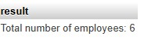
Lab 2: Create a PL/SQL block that calculates the total sales from an orders table.
CREATE TABLE orders ( order_id INT AUTO_INCREMENT PRIMARY KEY, customer_id INT, order_amount DECIMAL(10,2), order_date DATE
);
INSERT INTO orders (customer_id, order_amount, order_date)
VALUES
(1, 250.50, '2025-11-01'),
(2, 450.00, '2025-11-05'),
(1, 300.75, '2025-11-10');
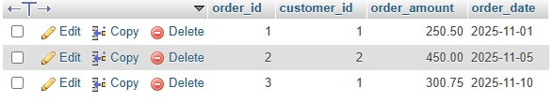
DELIMITER $$

CREATE PROCEDURE get_total_sales()
BEGIN
DECLARE total_sales DECIMAL(10,2);

SELECT SUM(order_amount) INTO total_sales
FROM orders;

SELECT CONCAT('Total sales: ', total_sales) AS result;
END$$

DELIMITER ;

-- Call the procedure
CALL get_total_sales();
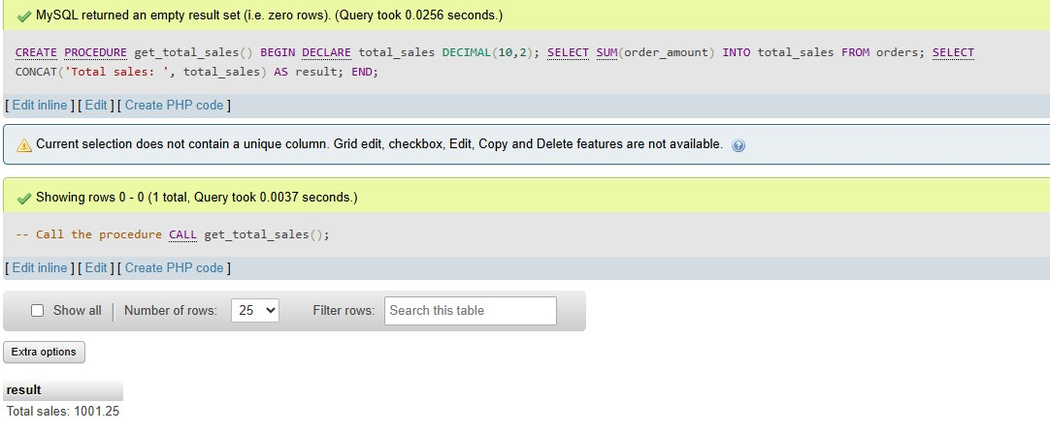

17. PL/SQL Control Structures
Theory Questions:
1. What are control structures in PL/SQL? Explain the IF-THEN and LOOP control structures.

Control Structures in PL/SQL
Control structures are programming constructs in PL/SQL that allow you to control the flow of execution in a program. They help you make decisions, repeat statements, or handle exceptions.

1. IF-THEN Control Structure
Used to execute statements conditionally based on a boolean expression.
Syntax:
IF condition THEN
-- statements to execute if condition is TRUE
ELSIF another_condition THEN
-- statements if another_condition is TRUE
ELSE
-- statements if all conditions are FALSE END IF;
Example:
DECLARE
salary NUMBER := 60000;
BEGIN
IF salary > 50000 THEN
DBMS_OUTPUT.PUT_LINE('High salary');
ELSE
DBMS_OUTPUT.PUT_LINE('Low salary');
END IF;
END; /

2. LOOP Control Structure
Used to repeat a block of statements multiple times until a condition is met.
Types of loops in PL/SQL:
- Simple _{LOOP} – indefinite loop, must use _{EXIT} to stop.
- _{WHILE} loop – repeats while a condition is true.
- _{FOR} loop – repeats a fixed number of times.
Simple LOOP Example:
DECLARE
i NUMBER := 1;
BEGIN
LOOP
DBMS_OUTPUT.PUT_LINE('Count: ' || i); i := i + 1;
EXIT WHEN i > 5;
END LOOP;
END;
/
Output:
Count: 1
Count: 2
Count: 3
Count: 4
Count: 5
2. How do control structures in PL/SQL help in writing complex queries? 1. Conditional Execution o Using _{IF-THEN-ELSE}, you can run different SQL statements depending on specific conditions.
o Example: Apply different discounts based on order amount.
- Repetition of Tasks o _{LOOP}, _{WHILE}, and _{FOR} allow executing SQL statements multiple times automatically. o Example: Process all employees’ salaries in a loop without writing multiple queries.
- Dynamic Decision Making o Control structures enable decision-making within a block, making queries adaptable to different situations.
o Example: Update only employees meeting certain criteria dynamically.
- Modular and Readable Code o Instead of writing long, repeated SQL statements, control structures make your code organized and easier to maintain.
- Error Handling Integration o Can be combined with _{EXCEPTION} blocks to handle errors while executing multiple or conditional SQL operations.
LAB EXERCISES:
Lab 1: Write a PL/SQL block using an IF-THEN condition to check the department of an employee. DELIMITER $$

CREATE PROCEDURE check_employee_department(IN empId INT)
BEGIN
DECLARE emp_dept VARCHAR(50);

SELECT d.dept_name INTO emp_dept
FROM employees e
JOIN departments d ON e.dept_id = d.dept_id
WHERE e.emp_id = empId;

IF emp_dept = 'Sales' THEN
SELECT 'Employee belongs to Sales department' AS result;
ELSE
SELECT 'Employee belongs to another department' AS result;
END IF;
END$$

DELIMITER ;
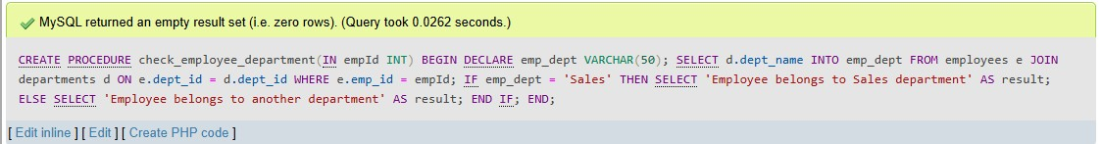
-- Call the procedure
CALL check_employee_department(1);
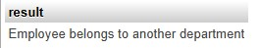
Lab 2: Use a FOR LOOP to iterate through employee records and display their names. DELIMITER $$

CREATE PROCEDURE display_employee_names()
BEGIN
DECLARE done INT DEFAULT 0;
DECLARE emp_name VARCHAR(50);

DECLARE emp_cursor CURSOR FOR
SELECT emp_name FROM employees; -- correct table name

DECLARE CONTINUE HANDLER FOR NOT FOUND SET done = 1;

OPEN emp_cursor;

read_loop: LOOP
FETCH emp_cursor INTO emp_name;
IF done = 1 THEN
LEAVE read_loop;
END IF;
INSERT INTO employees (emp_name) VALUES (emp_name); END LOOP;

CLOSE emp_cursor;

SELECT * FROM employees;

TRUNCATE TABLE employees;
END$$

DELIMITER ;
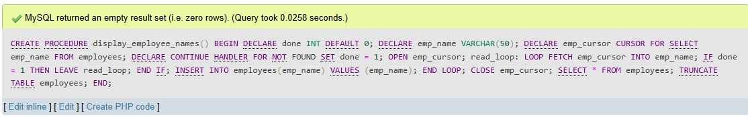
CALL display_employee_names();

18. SQL Cursors
Theory Questions:
1. What is a cursor in PL/SQL? Explain the difference between implicit and explicit cursors.

Implicit Cursor
- Automatically created by Oracle for every SQL statement (like _{INSERT}, _{UPDATE}, _{DELETE}, _{SELECT} INTO).
- Managed by Oracle; you don’t need to declare, open, fetch, or close it.
- Used when the SQL statement returns a single row.

Explicit Cursor
- Manually declared and controlled by the programmer.
- Used for queries that return multiple rows.
- Requires steps: DECLARE → OPEN → FETCH → CLOSE
2. When would you use an explicit cursor over an implicit one?
You would use an explicit cursor when you need to handle a query that returns more than one row and you want detailed control over how each row is processed. Explicit cursors let you open, fetch, and close the cursor manually, making it easier to loop through rows one by one. They are useful when you need to perform calculations, apply conditions, or execute logic for each row of the result set.
In contrast, implicit cursors are automatically created by Oracle for simple SQL statements and are suitable only when the statement returns a single row or when no row-by-row processing is needed.
LAB EXERCISES:
Lab 1: Write a PL/SQL block using an explicit cursor to retrieve and display employee details.
DELIMITER //
CREATE PROCEDURE display_employee_details()
BEGIN
DECLARE v_emp_id INT;
DECLARE v_emp_name VARCHAR(50);
DECLARE v_dept_id INT;
DECLARE v_salary INT;
DECLARE v_last_modified DATETIME;
DECLARE done INT DEFAULT 0;
DECLARE emp_cursor CURSOR FOR
SELECT emp_id, emp_name, dept_id, salary, last_modified FROM employees; DECLARE CONTINUE HANDLER FOR NOT FOUND SET done = 1;

OPEN emp_cursor;

read_loop: LOOP
FETCH emp_cursor INTO v_emp_id, v_emp_name, v_dept_id, v_salary, v_last_modified;
IF done THEN
LEAVE read_loop;
END IF;
SELECT CONCAT('Employee ID: ', v_emp_id,
', Name: ', v_emp_name,
', Dept: ', v_dept_id,
', Salary: ', v_salary,
', Last Modified: ', v_last_modified) AS employee_details; END LOOP;

CLOSE emp_cursor;
END//
DELIMITER ;
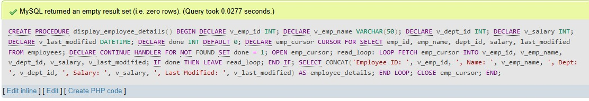
CALL display_employee_details();
Lab 2: Create a cursor to retrieve all courses and display them one by one.
DELIMITER //
CREATE PROCEDURE display_courses()
BEGIN
DECLARE v_course_id INT;
DECLARE v_course_name VARCHAR(100);
DECLARE v_course_duration VARCHAR(50);
DECLARE done INT DEFAULT 0;

DECLARE c_cursor CURSOR FOR
SELECT course_id, course_name, course_duration FROM courses;

DECLARE CONTINUE HANDLER FOR NOT FOUND SET done = 1;

OPEN c_cursor;

c_loop: LOOP
FETCH c_cursor INTO v_course_id, v_course_name, v_course_duration;

IF done THEN
LEAVE c_loop;
END IF;

SELECT CONCAT('ID: ', v_course_id,
', Name: ', v_course_name,
', Duration: ', v_course_duration) AS course_details; END LOOP;

CLOSE c_cursor;
END //
DELIMITER ;
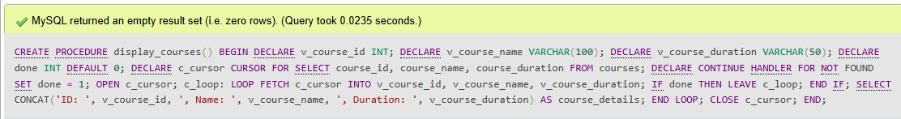
CALL display_courses();

19. Rollback and Commit Savepoint
Theory Questions:
1. Explain the concept of SAVEPOINT in transaction management. How do ROLLBACK and COMMIT interact with savepoints?
A SAVEPOINT is a marker inside a transaction that allows you to rollback part of the transaction, instead of rolling back the entire transaction. It acts like a checkpoint.

Purpose of SAVEPOINT
- To divide a long transaction into smaller parts.
- To undo only a specific portion if something goes wrong.
- To avoid losing the whole transaction.

How ROLLBACK interacts with SAVEPOINT
ROLLBACK TO savepoint_name
- Undo only the changes made after that savepoint
- Everything before the savepoint remains safe
- The transaction continues and can still be committed later
Example:
SAVEPOINT sp1;
-- some queries ROLLBACK TO sp1;

How COMMIT interacts with SAVEPOINT
- _{COMMIT} saves all changes permanently
- Once committed, all savepoints inside the transaction are removed
- You cannot rollback to a savepoint after commit
Example:
COMMIT;
-- all savepoints are cleared

Short, exam-perfect summary
- SAVEPOINT creates a checkpoint inside a transaction.
- ROLLBACK TO SAVEPOINT undoes only the changes after that checkpoint.
- COMMIT saves all changes permanently and removes all savepoints.
2. When is it useful to use savepoints in a database transaction?
Savepoints are useful when you want to control large or complex transactions and avoid rolling back the entire transaction. They allow partial rollback and help maintain data consistency.
⭐ Savepoints are useful in these situations:

1️ ⃣ Large transactions with multiple steps
When a transaction has many operations, you can set savepoints to undo only the part that fails instead of starting over.
2️ ⃣ Optional operations inside a transaction
If some steps may fail but the rest should continue safely.
3️ ⃣ Error handling inside a transaction
You can roll back only the portion where the error occurred and continue the rest.

4️ ⃣ Testing small parts of a transaction
During development or debugging, savepoints help test each section without losing everything. 5️ ⃣ Complex business logic
For example, inserting into multiple related tables — if one insert fails, you can roll back just that section.

6️ ⃣ Partial undo requirement
When you need to reverse only a specific part of the transaction and keep the previous operations.
LAB EXERCISES:
Lab 1: Perform a transaction where you create a savepoint, insert records, then rollback to the savepoint.
START TRANSACTION;

INSERT INTO courses (course_name, course_duration)
VALUES ('Python Basics', '3 Months');

SAVEPOINT sp1;

INSERT INTO courses (course_name, course_duration)
VALUES ('Data Science', '6 Months');

INSERT INTO courses (course_name, course_duration)
VALUES ('Machine Learning', '5 Months');

ROLLBACK TO sp1;
COMMIT;
SELECT COUNT(*) FROM courses;
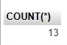
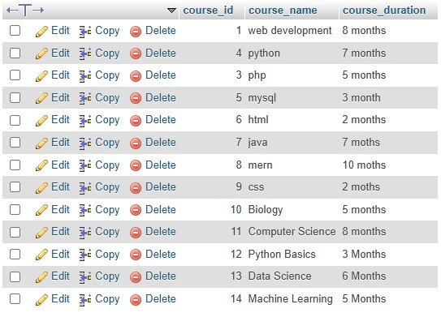

Lab 2: Commit part of a transaction after using a savepoint and then rollback the remaining changes.
START TRANSACTION;

INSERT INTO courses (course_name, course_duration)
VALUES ('Python Basics', '3 Months');

SAVEPOINT sp1;

INSERT INTO courses (course_name, course_duration)
VALUES ('Data Science', '6 Months'),
('Machine Learning', '5 Months');

ROLLBACK TO sp1;

COMMIT;
SELECT * FROM courses;

